Name: Date: Period:

Physics Ms. Nigro

**Reaction Time Lab**

**OBJECTIVES:**

To determine reaction time.

To calculate the change in reaction time in different situations.

**COLLECT THE DATA**

Rest your forearm on your desk.

Spread your index finger and thumb 5 cm apart.

Your partner will hold a ruler between your fingers above you so your fingers are at the 0 cm mark.

Your partner will let go of the ruler at any moment without warning you and you must catch the ruler as fast as you can.

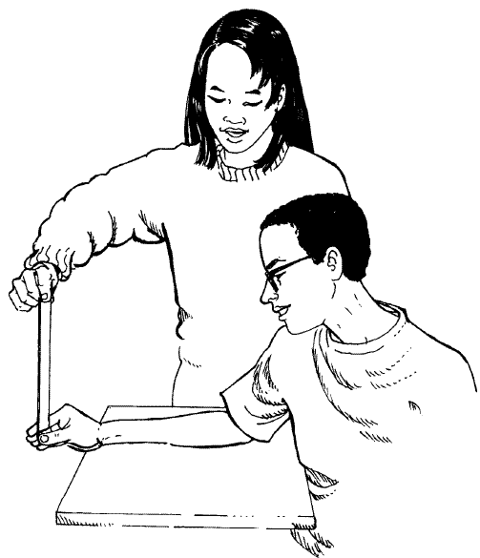You will repeat this experiment three times. Write down the spots where you caught the ruler and average them. Convert to meters. Fill out this information in the chart below.

Switch roles with your partner.

|  |  |  |
| --- | --- | --- |
| **Trial** | **Displacement (cm)** | **Displacement (m)** |
| 1 |  |  |
| 2 |  |  |
| 3 |  |  |
| **Average** |  |  |

**CALCULATE REACTION TIME**

List the values below including fundamental units of the metric system. Use the average displacement from your experiment in meters.

|  |  |
| --- | --- |
|  |  |
|  |  |
|  |  |
|  | **?** |

Choose a linear motion equation, substitute with units and solve with units.

**HOW DOES TEXTING AFFECT YOUR REACTION TIME?**

Repeat the experiment, but this time you will text the alphabet to a friend while you wait to catch the ruler. The alphabet must be correct or it will not count and you must repeat the experiment.

|  |  |  |
| --- | --- | --- |
| **Trial** | **Displacement (cm)** | **Displacement (m)** |
| 1 |  |  |
| 2 |  |  |
| 3 |  |  |
| **Average** |  |  |

|  |  |
| --- | --- |
|  |  |
|  |  |
|  |  |
|  | **?** |

Show your work below to calculate your reaction time while you are distracted.

**Questions:**

1. Imagine you are driving on a straight road at a constant speed of 45 mph (20 m/s). You suddenly see an obstacle in the road. Using your original reaction time, calculate how far you will travel before your foot touches the brake. Show all your work, including an equation, substitution with units and answer with units.
2. Now imagine you are driving while texting. How much further will you travel before your foot touches the brake?
3. What did you learn from this activity?