BELLMORE-MERRICK CENTRAL HIGH SCHOOL DISTRICT
W. C. Mepham High School

Ms. Nigro
Regents Physics
Newton’s Laws Unit
Force of Friction Lab
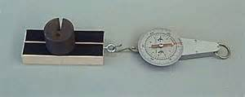
Objective: To determine the factors that affect friction.

Materials:
Wood block
1 kg mass
Newton scale

Procedure:
- Slide the wood block across a surface at a constant speed and note the reading on the Newton scale. This reading is the force of friction between the block and the surface:

Force of friction (N):

- Slide the wood block across the surface at a constant speed but faster than in step 1. Note the force of friction.

Force of friction at a higher speed (N):

- Slide the wood block at the original speed but place a 1kg mass on it. Note the force of friction.

Force of friction with 1 kg mass (N):

- Slide the wood block at the original speed and without the mass but turn it on its narrower side.

Force of friction on the thinner side (N):

- Slide the wood block at the original speed and without the mass but use the side with sand paper.

Force of friction with sand paper (N):

- Which factors affect the force of friction between two sliding surfaces?

