**FORCES**

Force: A pull or push by interacting objects Unit: Newton

|  |  |  |
| --- | --- | --- |
| **Types of Forces** | | |
| **Contact Forces** | | |
| Friction (Ff)  *When two surfaces slide against each other* | Opposite direction to motion | ***v*** |
| Tension (T)  *When pulling with a rope or string* | Along the rope or string | [http://www.physicsclassroom.com/class/vectors/u3l1d4.gif](http://www.google.com/url?sa=i&rct=j&q=&esrc=s&frm=1&source=images&cd=&cad=rja&docid=j52EM1LIpDf8UM&tbnid=qo6We-Q6UWqIpM:&ved=0CAUQjRw&url=http%3A%2F%2Fwww.physicsclassroom.com%2Fclass%2Fvectors%2Fu3l1d.cfm&ei=fw10UvyXI6K0sATujIHADg&psig=AFQjCNGXm5eUOLS14dbQUfwXowqqeUod2g&ust=1383423741921537)  T |
| Air Resistance  (Fair)  *Whenever there is motion* | Opposite direction to motion | ***v***  Fair |
| Normal Force  (FN)  *Force applied by any surface* | Perpendicular to the surface | FN  FN |
| Applied Force  (Fa)  *Any push or pull by a person or object* | In the direction specified by each situation | Fa  Fa |
| Elastic Force (Fs)  *Force by compressed or stretched spring* | Parallel to the elongation or compression of the spring | [http://www.phys.ttu.edu/~rirlc/Image554.gif](http://www.google.com/url?sa=i&rct=j&q=&esrc=s&frm=1&source=images&cd=&cad=rja&docid=RogsDxUalW3r8M&tbnid=aW5XpSctB4IfZM:&ved=0CAUQjRw&url=http%3A%2F%2Fwww.phys.ttu.edu%2F~rirlc%2FLecture10.html&ei=vw90UtGIOPOvsQSd9ICoBQ&psig=AFQjCNH1HnN5xlgDdCZikaLu3PZVvVcmJw&ust=1383424272749830) |
| **Forces at a Distance** | | |
| Gravity  *Force of attraction between two objects* | From the center of one object towards the center of the other object | Fg |
| Electric  *Attraction or repulsion by charges* | TBA |  |
| Magnetic  *Attraction or repulsion between ferromagnets* | TBA |  |

[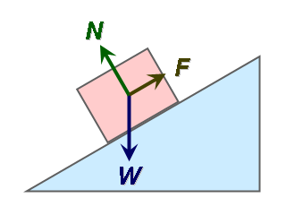](http://www.google.com/url?sa=i&rct=j&q=&esrc=s&frm=1&source=images&cd=&cad=rja&docid=4dTKlME5WDWzTM&tbnid=wKdaMZrtiL-JxM:&ved=0CAUQjRw&url=http%3A%2F%2Fen.wikipedia.org%2Fwiki%2FFile%3AFree_body_diagram_ctrmass.png&ei=bxR0Utm2FK_gsATJioHoAw&psig=AFQjCNG63nRr3k60t00XjXP1fdKzQGRBYg&ust=1383425059910738)[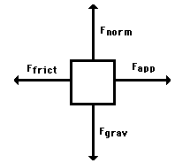](http://www.google.com/url?sa=i&rct=j&q=&esrc=s&frm=1&source=images&cd=&cad=rja&docid=PNEciaemBOuCFM&tbnid=DeY9nIZPajTdAM:&ved=0CAUQjRw&url=http%3A%2F%2Fwww.physicsclassroom.com%2Fclass%2Fnewtlaws%2Fu2l2c.cfm&ei=FhN0Us3iM7HdsAT70YGQBA&psig=AFQjCNG63nRr3k60t00XjXP1fdKzQGRBYg&ust=1383425059910738)

