FOUNDATIONS/PRINCIPLES OF ENGINEERING
REFERENCE TABLES

$Ideal Mechanical Advantage$ $D_{E}=distance to the effort$
$IMA=\frac{D_{E}}{D_{R}}$ $D_{R}=distance to the resistance$
$Actual Mechanical Advantage$ $F_{R}=resistance force$
$AMA= \frac{F_{R}}{F_{E}}$ $F_{E}=effort force$

$Efficiency= \frac{AMA}{IMA}x100$ $Compound Machines IMA=\left({MA}_{1}\right)\left({MA}_{2}\right)\left({MA}_{3}\right)…$
$$Torque=Fd_{⊥}$$

$$Moment=Fd_{⊥}$$
$$Pulley IMA=\# of strands supporting the load-1 (if directional advantage)$$

$Inclined Plane$ $Wedge$

$IMA=\frac{L_{(slope)}}{H}$ $IMA=\frac{L_{(⊥height)}}{H}$

$L_{\left(slope\right)}=slope length H=height of incline$ $L_{\left(⊥height\right)}=Length of wedge$
$H=thickness of wedge$
Gears, Sprockets with Chains and Pulleys with Belts Ratios
Lever

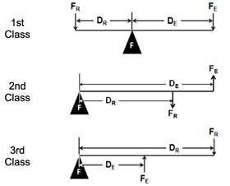
$GR= \frac{N_{out}}{N_{in}}=\frac{d_{out}}{d_{in}}=\frac{τ_{out}}{τ_{in}}=\frac{ω_{in}}{ω_{out}}$

$Compound Gears:$
${GR}_{TOTAL}=\left(\frac{B}{A}\right)\left(\frac{D}{C}\right)$

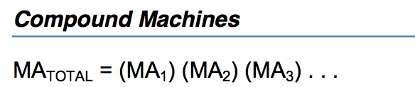

$$Screw$$
$$IMA=\frac{C}{Pitch}$$

$$Pitch= \frac{1}{TPI}$$

$$C=circumference$$
$$Pitch=distance between threads$$
$$TPI=Threads per Inch$$
$$r=radius$$
$$d=diameter$$

When installing with a
wrench
When installing with a
screwdriver

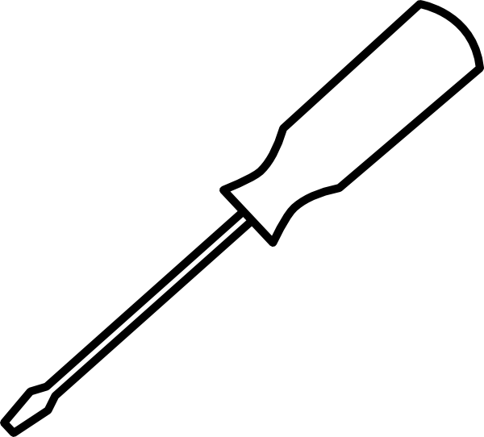
d

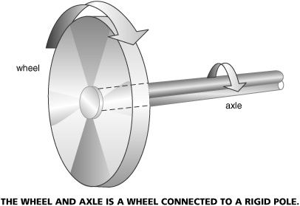
Wheel and Axle

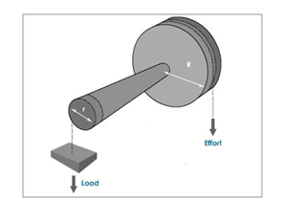

Resistance
Effort

Effort
Resistance

For Effort on the Axle

$$IMA= \frac{C_{axle}}{C_{wheel}}=\frac{d_{axle}}{d_{wheel}}=\frac{r_{axle}}{r_{wheel}}$$

$$C=circumference$$

$$d=diameter$$

$$r=radius$$
For Effort on the Wheel

$$IMA= \frac{C_{wheel}}{C_{axle}}=\frac{d_{wheel}}{d_{axle}}=\frac{r_{wheel}}{r_{axle}}$$

$$C=circumference$$

$$d=diameter$$

$$r=radius$$

$Kinematics:$ $\overline{v}=\frac{d}{t}$
$\overline{v}$ = average speed/average velocity
v_{f} = final velocity
v_{i} = initial velocity
a = acceleration
t = time
d = distance/displacement
x = range (for projectiles only)
$θ$ = theta, angle measured to the horizon
g = acceleration due to gravity
$v_{f}=v_{i}+at$

${v_{f}}^{2}={v_{i}}^{2}+2ad$

$d=v_{i}t+\frac{1}{2}at^{2}$

$x=\frac{{v_{i}}^{2}sin⁡(2θ)}{g} v_{i}=\sqrt{\frac{xg}{sin\left(2θ\right)}}$ $θ=\frac{\sin^{-1}\left(\frac{xg}{{v_{i}}^{2}}\right)}{2}$
$$g=9.81 m/{s^{2}}$$
$$g=32.15 {ft}/{s^{2}}$$

$$Electricity$$
V=Voltage
I = Current
R= Resistance
W = work
P = Power
C = Capacitance

$$V=IR$$

$$P_{(electrical)}=VI=I^{2}R=\frac{V^{2}}{R}=\frac{W}{t}$$

$$W_{(electrical)}=VIt=I^{2}Rt=\frac{V^{2}t}{R}$$

Series total Resistance
$$R_{T}=R_{1}+R_{2}+R_{3}…$$

Parallel total Resistance
$$R_{T}={\left({R_{1}}^{-1}+{R_{2}}^{-1}+{R_{3}}^{-1}…\right)}^{-1}$$

Kirchoff’s Current Law
Statics and Newton’s Second Law:
$$F_{net}=ma$$

$$M=Fd_{⊥}$$

$$2J=M+R$$

In Static Equilibrium
$$\sum{F_{x}=0}$$

$$\sum{F_{y}=0}$$

$$\sum{M_{point}=0}$$

$$I_{T}=I_{1}+I_{2}+I_{3}…$$
F_{net} = net Force
m = mass
a = acceleration
M = moment
F = force
$d_{⊥}$ = perpendicular distance
J= Joints
M = members
R = Reaction Forces

F_{x} = forces in the “x”
F_{y} = forces in the “y”
M_{point} = moments about a point
= sum
Kirchoff’s Voltage Law
$$V_{T}=V_{1}+V_{2}+V_{3}…$$

Parallel total Capacitance
$$C_{T}=C_{1}+C_{2}+C_{3}…$$

Series total Capacitance
$$C_{T}={\left({C_{1}}^{-1}+{C_{2}}^{-1}+{C_{3}}^{-1}…\right)}^{-1}$$

Mechanical Energy:
KE = Kinetic Energy
m = mass
v = velocity
PE = Potential Energy
g = acceleration due to gravity
h = height
W = work
F = force
d = distance
t = time
P = Power
P_{out} = output power
P_{in} = input power

Q = Energy transfer
m = mass
c = specific heat capacity
t = time
T = Temperature
P = Rate of Energy transfer
A = area
k = Thermal Conductivity
L = Thickness
U = Thermal Conductance
R = Thermal Resistance
е = emissivity constant of the material
σ = Stefan’s Constant $5.6696x{10}^{-8}\frac{W}{m^{2}K^{4}}$

$$KE=\frac{1}{2}mv^{2}$$

$$PE=mgh$$

$$W_{(mechanical)}=Fd$$

$$P_{(mechanical)}=\frac{W}{t}=\frac{Fd}{t}=Fv$$

Efficiency:
$$\frac{P_{out}}{P_{in}}x100$$

Thermodynamics:

$$Q=mc∆T$$

$$P=\frac{Q}{∆t}$$

$$P=\frac{kA∆T}{L}$$

$$U=\frac{P}{A∆T}$$

$$R=\frac{1}{U}$$

$$P_{net}=σAe\left({T_{2}}^{4}-{T_{1}}^{4}\right)$$

Temperature Conversions:

T_{R} = Temperature in Rankine

T_{F} = Temperature in Farenheit

T_{C} = Temperature in Celsius

T_{K} = Temperature in Kelvin
$T_{R}=T_{F}+460$

$$T_{F}=\frac{9}{5}T_{C}+32$$

$$T_{C}=\frac{5}{9}\left(T_{F}-32\right)$$

$$T_{K}=T_{C}+273.15$$

Fluid Power
Q = Flow Rate
V = Volume
v = velocity
t = time
d = distance
A = area
P = Pressure
F_{out} = output force
F_{in} = input force

P = Pressure
V = Volume
T = Temperature

I_{xx} = Moment of Inertia
b = base
h = height
$∆$_{Max} = Deflection
F = Force
L = Length
E = Modulus of Elasticity
$σ$ = stress
A = Area
ε = strain
δ = deformation

$$Q=\frac{V}{t}$$

$$v=\frac{d}{t}$$

$$Q=vA$$

$$P=\frac{F}{A}$$

$$MA=\frac{F_{out}}{F_{in}}$$

$$Absolute Pressure=Gauge Pressure+14.7psi$$

Boyle’s Law: (Note: Pressure must be absolute)
$$P_{1}V_{1}=P_{2}V_{2}$$

Charles’ Law: (Note: Temperature must be absolute)
$$\frac{V_{1}}{T_{1}}=\frac{V_{2}}{T_{2}}$$

Gay Lussac’s Law: (Note: Pressure and Temperature must be absolute)
$$\frac{P_{1}}{T_{1}}=\frac{P_{2}}{T_{2}}$$

Stress, Strain, Deformation
$$I_{xx}=\frac{bh^{3}}{12}$$

$$∆_{Max}=\frac{FL^{3}}{48EI}$$

$$σ=\frac{F}{A}$$

$$δ=\frac{FL}{AE}$$

$$ε=\frac{δ}{L}$$

$$E=\frac{σ}{ε}$$

Centroids:
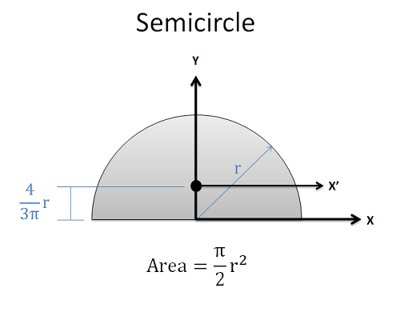
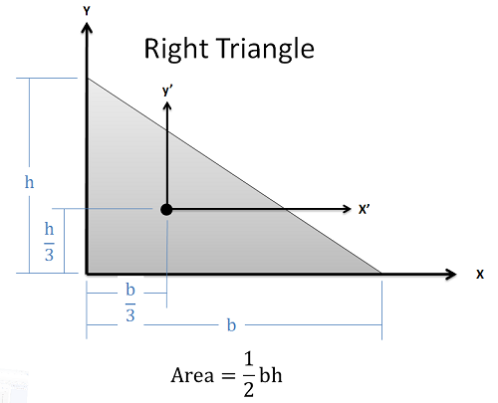
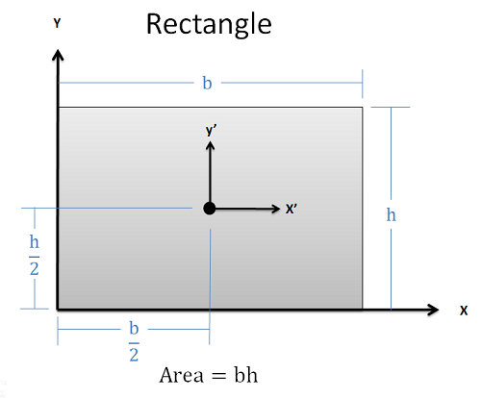

Centroids of Complex Shapes:

$$\overline{x}=\frac{\sum{x_{i}A_{i}}}{\sum{A_{i}}} \overline{y}=\frac{\sum{y_{i}A_{i}}}{\sum{A_{i}}} \overline{z}=\frac{\sum{z_{i}A_{i}}}{\sum{A_{i}}}$$

$Geometry$
C = circumference
r = radius
d = diameter
b = base
h = height
A = area

$$a^{2}+b^{2}=c^{2}$$
$$C=2πr=πd$$
$$A_{rectangle}=bh$$
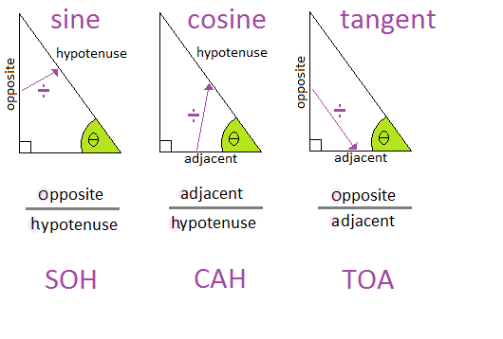
$A_{circle}=πr^{2}=\frac{π}{4}d^{2}$

$$Basic Conversions$$
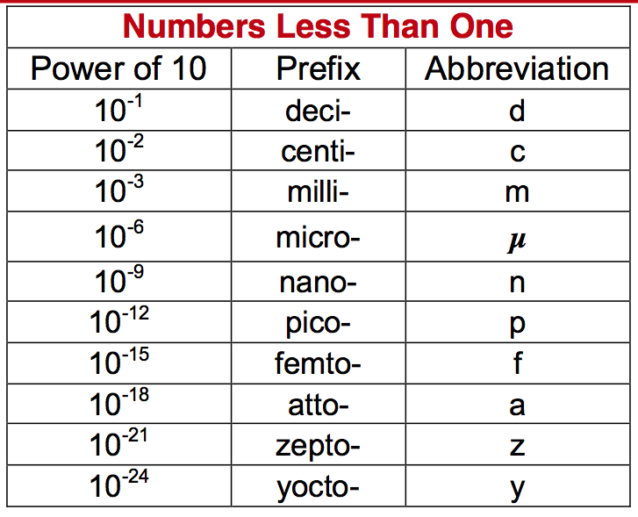
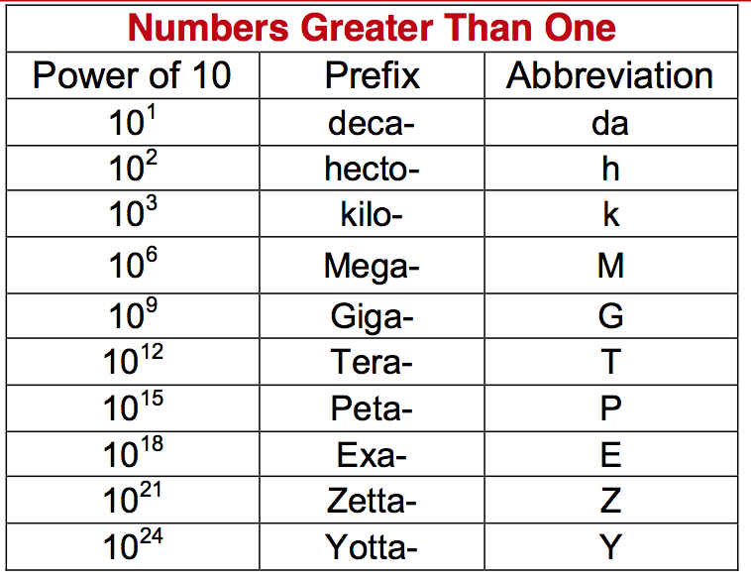
$1 m=3.28 ft$
$1 km=0.621 mi$
$$1 in=2.54 cm$$
$$1 mi=5280 ft$$
$$1 yd=3 ft$$
$$1 kg=2.205 lb$$
$$1N=0.225 lb$$
$$1 mile=1609.34 m$$
$$1 gallon=231 {in}^{3}$$

