Name _______________________ Date ________

<http://www.wisc-online.com/objects/ViewObject.aspx?ID=MSR4303>

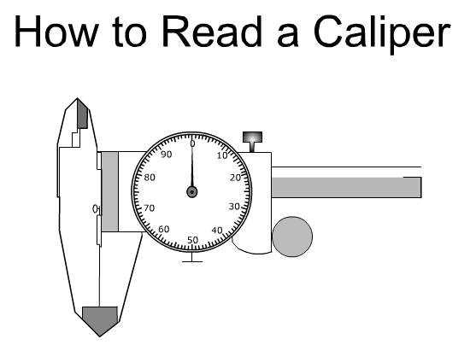

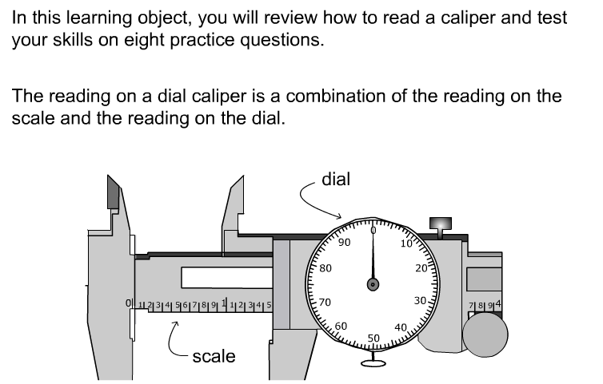

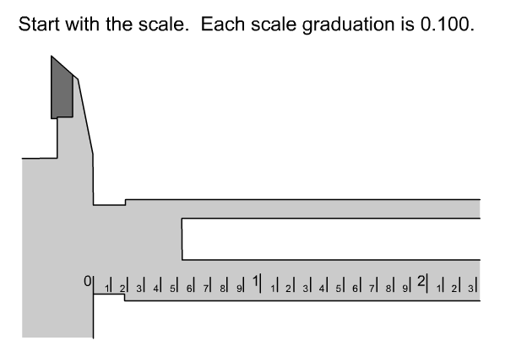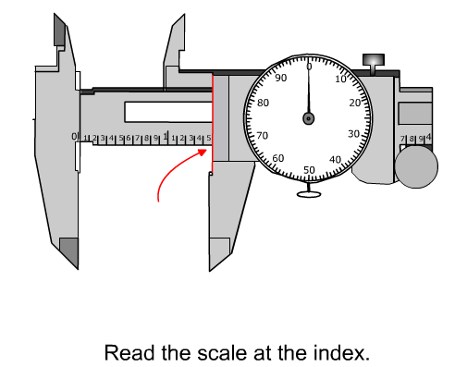

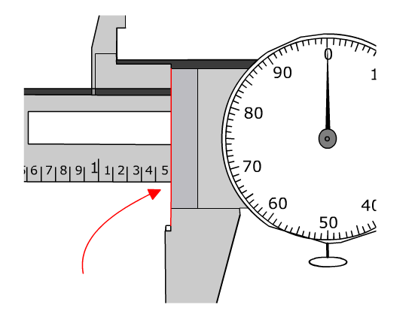 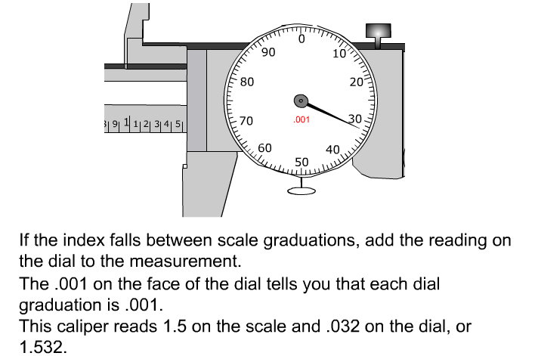

1. 2.

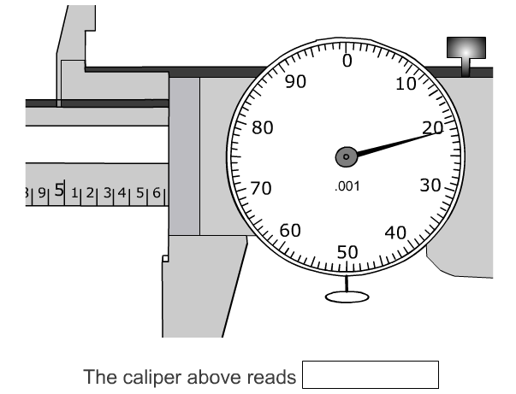 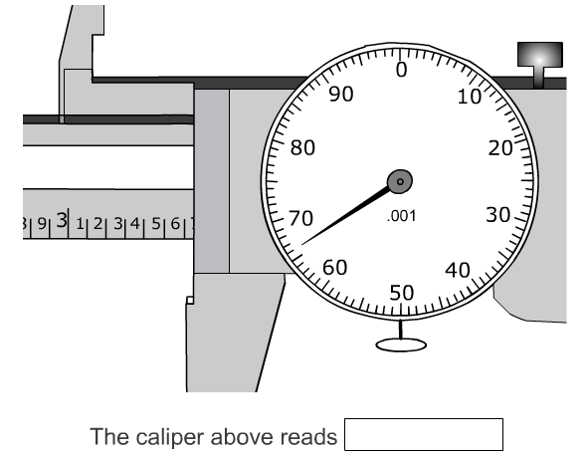

3. 4.

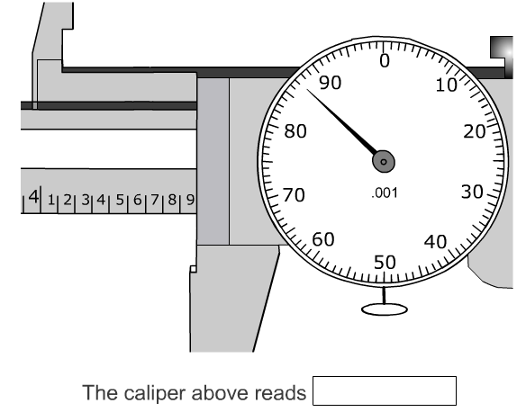 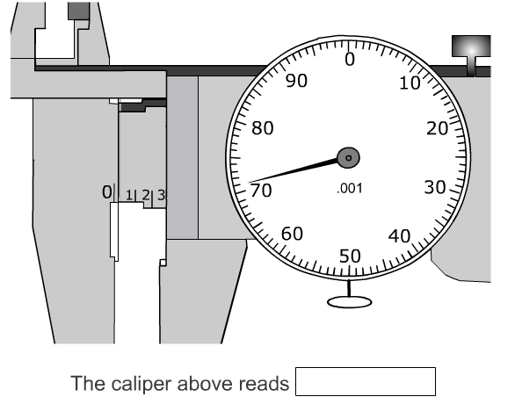

5. 6.

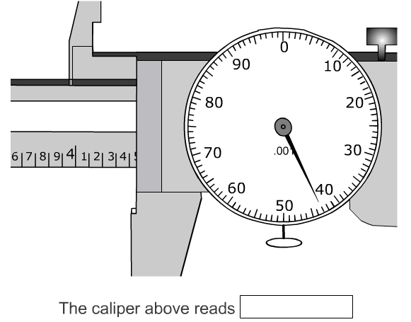 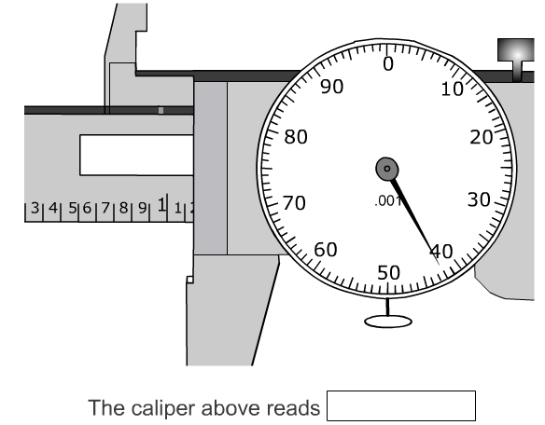

7. 8.

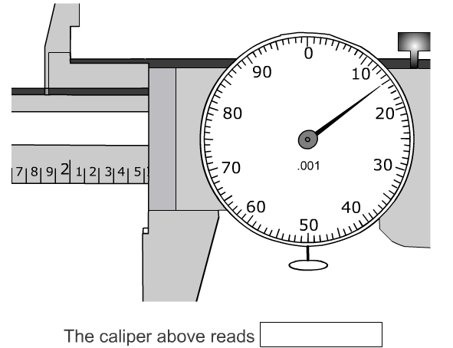 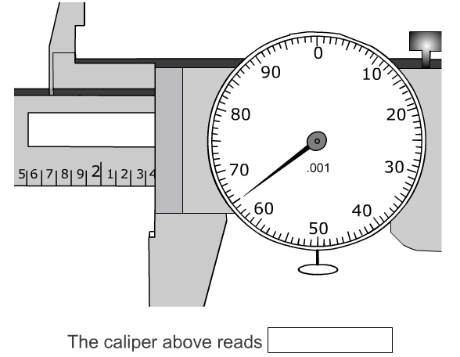

|  |  |  |  |
| --- | --- | --- | --- |
| Object | Your Measurement | Person 1 | Person2 |
| 1 |  |  |  |
| 2 |  |  |  |
| 3 |  |  |  |
| 4 |  |  |  |
| 5 |  |  |  |

Signatures: ____________________ ___________________